**Binary operations**

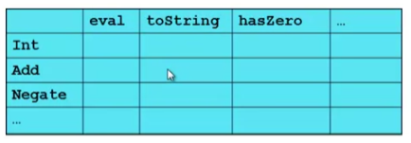

* Situation is more complicated if an operation is defined over multiple arguments that can have different variants
  + Can arise in original program or after extension
* Function decomposition deals with this much more simply…

**Example**

To show the issue:

* Include variants **String** and **Rational**
* (Re)define **Add** to work on any pair of Int, String, Rational
  + Concatenation if either argument of a String, else math

Now just defining the addition operation is a different 2D grid:

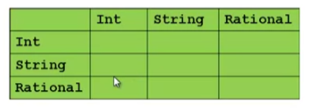

Note: binary – 2 operands

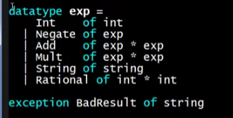

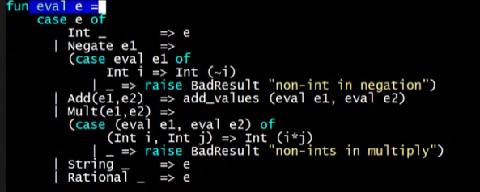

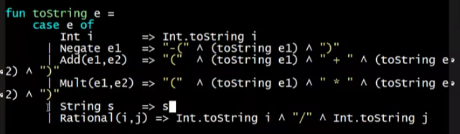

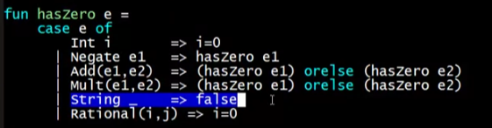

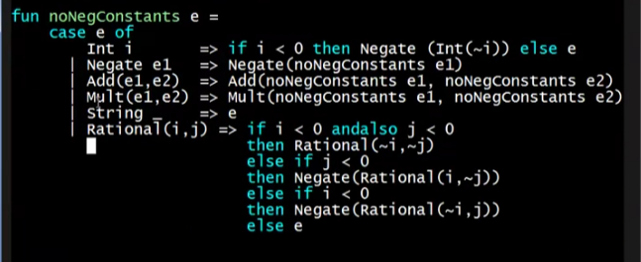

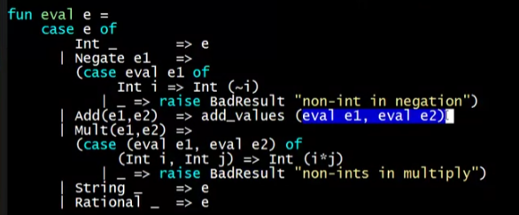

* Any combination is possible for Add

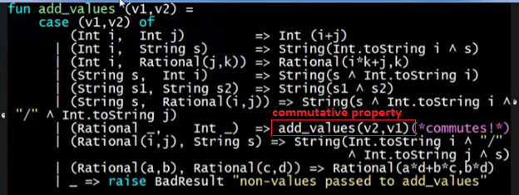

* Pattern-matching in add_values with different combinations